Project : Tableau Pulse

As you proceed with the assignment, follow the written instructions. Screenshots are provided ONLY as a reference.

Make sure you submit all screenshots with a clearly visible menu bar including the date and timestamp.

**Objective:** The goal of this project is to utilize the Superstore dataset to create interactive and insightful visualizations that provide a comprehensive view of key business metrics, such as sales performance, profit margins, and customer behavior, across different product categories and regions. By integrating Tableau Cloud and Tableau Pulse, the project also aims to generate real-time, customizable metrics that enable stakeholders to monitor trends and make informed decisions quickly. The dashboards and metrics will help streamline the analysis of sales data, track key performance indicators (KPIs), and identify opportunities for business growth and optimization.

Step 1: Connect to Dataset:

* Launch Tableau from your desktop.  
  Select the Superstore dataset and click "Connect" to start using the data.
* Select the Sample – Superstore data set. This is a sample dataset provided by Tableau.

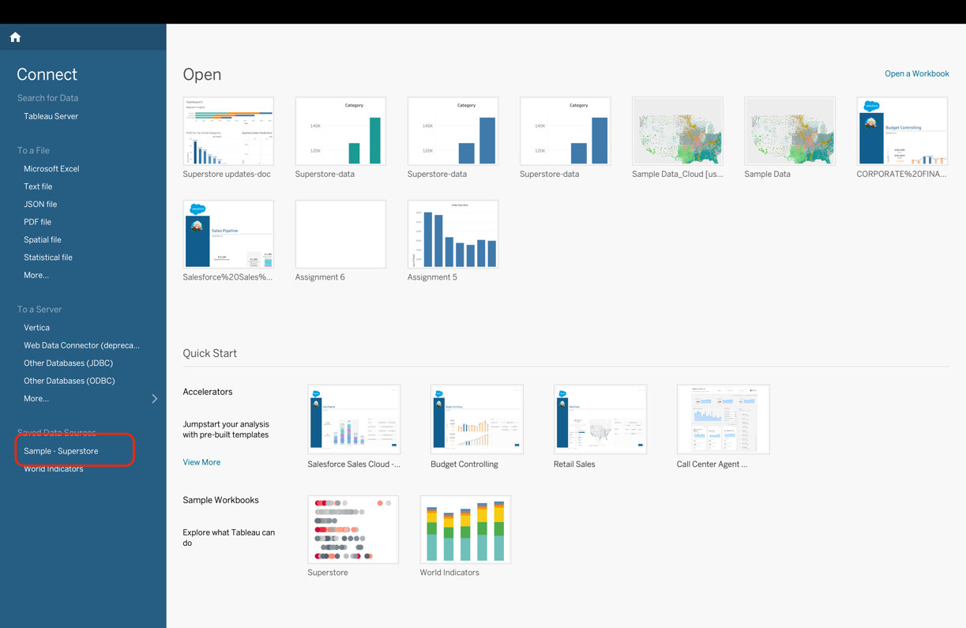

**Exploring the Dataset:**

Before creating visualizations, we will explore the Superstore dataset to understand its structure and key fields. The dataset includes various dimensions and measures, such as:

* **Dimensions:**
  + Order ID
  + Customer Name
  + Region
  + Product Category
  + Ship Mode
* **Measures:**
  + Sales
  + Profit
  + Quantity
  + Discount

**Step 2 : Creating Worksheets:**

* Create a new worksheet.
* We will calculate **Profit** for the **Subcategories**.
* Drag **Subcategory** from the list of dimensions and drop it into the **Columns** section. Drag **Profit** from the measures and drop it into the **Rows** section.
* Change the visualization type to **Bar Chart**.

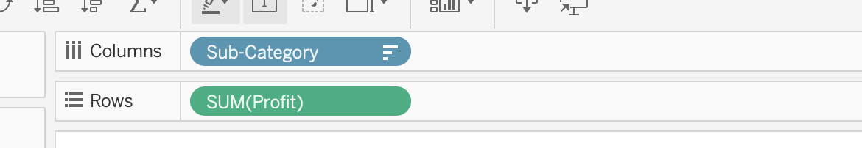

This will calculate the profit for all subcategories.

We need the Profit for only Top 10 subcategories. Now, to display only the **Top 10 Subcategories**:

* Drag the **Subcategory** field into the **Filters** pane.
* In the filter options, click on the **Top/Bottom** tab.
* Select **By Field**, choose **Profit**, and set the value to **10** to display the top 10 subcategories based on profit. Click on Ok.

* Now, Click on the **Profit** axis in the worksheet.
* Select the **Sort** icon that appears (upward arrow) to sort the values in descending order.

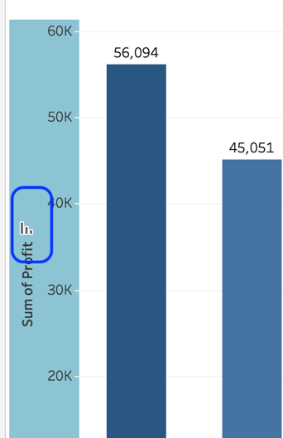

* Click on the Labels in the Mark Shelf. Click on the Show Mark Labels option.

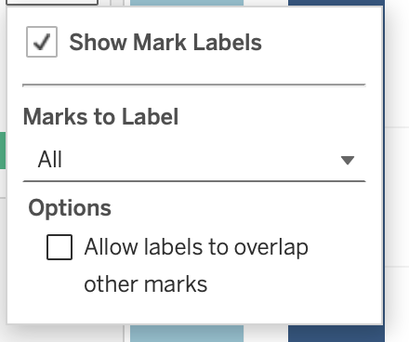

* Drag **Profit** and drop it onto the **Color** option in the **Marks** shelf.

* Rename the sheet by clicking on the sheet as **Profit Analysis - <Student Name>**

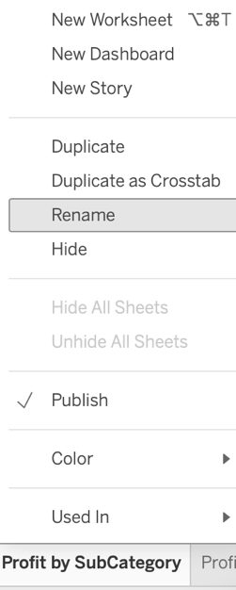

* Your graph should resemble this layout.

* Click on the **Card**, select the small arrow, and choose **Hide Card**.

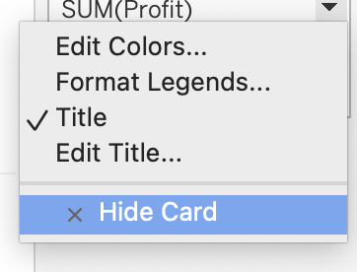

Question 1: Paste the screenshot of the resulting screen.What are the Top 10 Subcategories?

To conduct a **Depth Profit Analysis**, we need to calculate **Profit based on Region, State, and City**

Now, we will drill down into the profit details by calculating **Profit based on Regions**:

* Create a new worksheet.
* Drag **Region** from the list of dimensions and drop it into the **Columns** section.
* Drag **Profit** from the measures and drop it into the **Rows** section.
* Change the visualization type to **Bar Chart**.
* To calculate the **Top 10 Subcategories**, follow the same steps as before:
  + Drag **Subcategory** into the **Filters** pane.
  + Go to the **Top/Bottom** tab, select **By Field**, choose **Profit**, and set the value to **10**.
* Enable the **Show Mark Labels** by clicking on the **Label** button in the **Marks** card and checking the "Show Mark Labels" option. This will display profit values on the chart.
* Drag **Profit** and drop it onto the **Color** option in the **Marks** shelf.
* Rename the sheet **Profit Analysis by Region - <Student Name>**

Question 2: Paste the screenshot of the resulting screen.

Calculate **Profit based on States**:

* Create a new worksheet.
* Drag **State** from the list of dimensions and drop it into the **Columns** section.
* Drag **Profit** from the measures and drop it into the **Rows** section.
* Change the visualization type to **Bar Chart**.

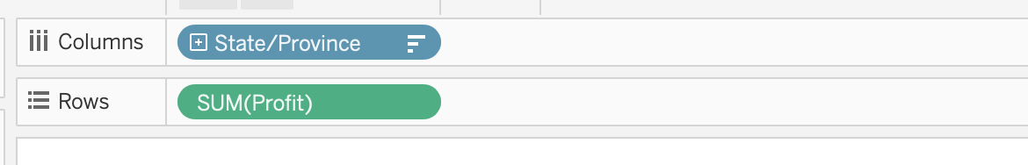

* To calculate the **Top 10 Subcategories**, follow the same steps as before.

Since we have multiple states, we will calculate the profit only for the top 10 states in the top 10 subcategories.

To calculate the **Top 10 States**, follow these steps:

* Drag **State** into the **Filters** pane.
* Click on the **Top/Bottom** tab, select **By Field**, choose **Profit**, and set the value to **10**.
* Enable the **Show Mark Labels** by clicking on the **Label** button in the **Marks** card and checking the "Show Mark Labels" option.
* Select the **Sort** icon that appears (upward arrow) to sort the values in descending order.
* Rename the sheet **Profit Analysis by State - <Student Name>**

Question 3: Paste the screenshot of the resulting screen.

Now, we will calculate **Profit based on City**:

* Create a new worksheet.
* Drag **City** from the list of dimensions and drop it into the **Columns** section.
* Drag **Profit** from the measures and drop it into the **Rows** section.
* Change the visualization type to **Bar Chart**.
* To calculate the **Top 10 Subcategories**, follow the same steps as before
* To calculate the **Top 10 Cities**, follow these steps:
  + Drag **City** into the **Filters** pane.
  + Click on the **Top/Bottom** tab, select **By Field**, choose **Profit**, and set the value to **10**.
* Enable the **Show Mark Labels**
* Select the **Sort** icon that appears (upward arrow) to sort the values in descending order.
* Rename the sheet **Profit Analysis by City- <Student Name>**

**Question 4: Paste the screenshot of the resulting screen.Which City has the Highest Profit? What is it?**

For the next part of our project, we will calculate **Sales**:

**Step 3: Calculating the Sales:**

* Create a new worksheet. This will be your 5th worksheet.
* Drag **Order Date** from the list of dimensions to the **Columns** section. Click on the three dots next to it and select **Quarter** to view quarterly sales.

* Drag **Sales** from the measures and drop it into the **Rows** section. Keep the default aggregation as **Sum** to calculate total sales.
* Make sure the Vizualization type is Line chart
* Drag the **Subcategory** field into the **Filters** pane.
* In the filter options window, click on the **Top/Bottom** tab.
* Select **By Field**, choose **Sales**, and set the value to **10** to display only the top 10 subcategories by sales.
* Drag **Order Date** from the list and drop it onto the **Color** option in the **Marks** card.

* Click on **View** and select **Entire View**.
* Rename the sheet as **Quarterly Sales Trends - <Your Name>**.
* Your graph should resemble this layout.

* Make sure the **Card** is visible in your graph.

**Question 5: Paste a screenshot of your screen showing the quarterly and yearly sales. Which quarter and year had the highest sales?**

Next step is Calculating **Monthly Sales** for the Top 10 Subcategories

* Create a new worksheet.
* Drag the **Order Date** field into the **Columns** section.
* Right-click on **Order Date**, and change it to **Month**.
* Change the visualization type to **Bar Chart**.
* Ensure you have the **Top 10 Subcategories** filter applied from the previous step.
* Drag **Sales** from the measures and drop it into the **Rows** section.
* This will calculate the **Monthly Sales** for the **Top 10 Subcategories**.
* Change the color of the graph, click on the **Color** button in the Marks card.
* Choose a color of your preference from the available options and click **OK** to apply the change.

* Sort the graph in descending order.
* Enable the **Show Mark Labels.**
* Rename the sheet as **Monthly Sales Trends - <Student Name>**.
* Your graph should resemble this layout.

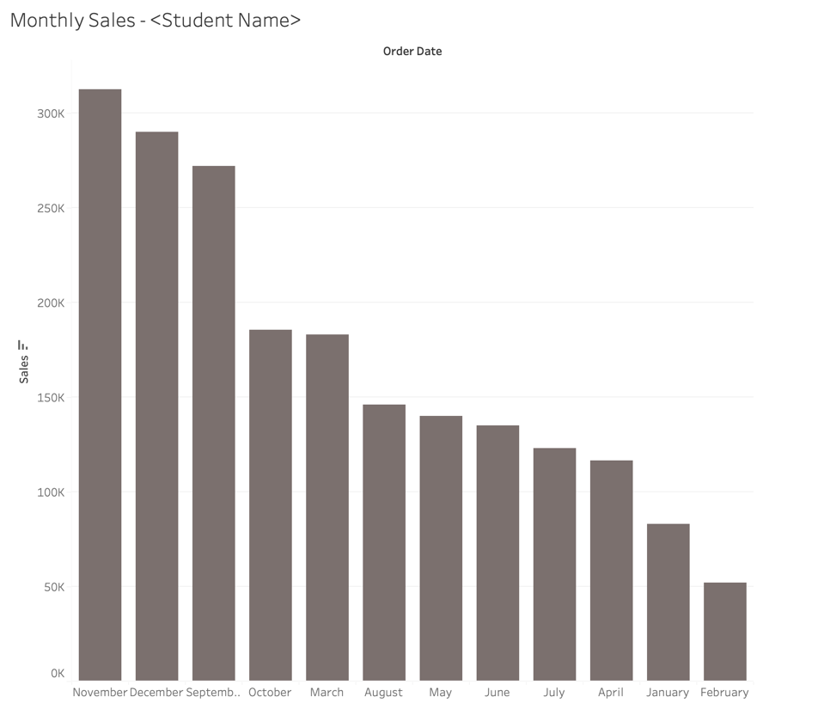

**Question 6: Paste the screenshot of the resulting screen.Which month has the highest sales?**

Calculating Daily Sales for the Top 10 Subcategories:

* Create a new worksheet.
* Drag the **Order Date** field into the **Columns** section.
* Right-click on **Order Date**, and choose **Day**.
* Drag **Sales** from the measures and drop it into the **Rows** section
* Change the visualization type to **Bar Chart**.
* Follow the previous steps to calculate total sales, for the **Top 10 Subcategories.**

**Filter for Top 10 Days:**

* Drag **Order Date** into the **Filters** pane.
* In the filter window, click on the **Top/Bottom** tab.
* Select **By Field**, choose **Sales**, and set the value to **10** to display only the top 10 days based on total sales.
* Enable the **Show Mark Labels**
* Adjust the graph colors to align with the ones applied to the **Monthly Sales Trends** graph.
* Sort the days by sales, click on the **Sales** axis and choose descending order.
* Rename the sheet as **Daily Sales Trends - <Student Name>**.

**Question 7: Paste the screenshot of the resulting screen.What are the days when Sales is above 70,000?**

Step 4: Calculating Segments Insights

* Create a new worksheet.
* From the dimensions list, drag **Segment** into the **Rows** section.
* From the measures, drag **Sales** into the **Columns** section.
* On the right side of the screen, click on the **Show Me** panel.
* From the available options, select the **Horizontal Bars** chart type.

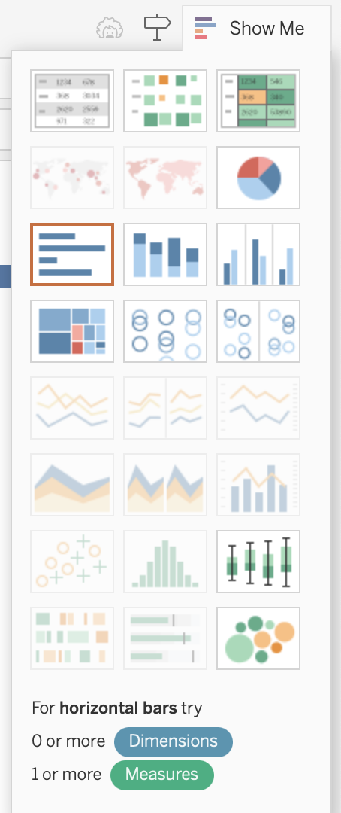

* From the dimensions list, drag **Category** and drop it into the **Color** option in the **Marks** shelf.
* Click on **Edit Colors** in the **Marks** shelf.
* Choose **Select Color Palette** and select **Orange - Gold** from the dropdown menu.

* Click on the ‘Assign Palette’.
* Rename the sheet as **Segment Insights - <Your Name>**.
* Click on the **Card**, select the small arrow, and choose **Hide Card**.
* Your graph should resemble the following layout.

* Make sure the **Card** is visible in your graph.

**Question 8: Paste the screenshot of the resulting screen.**

Calculate Top 15 Customers:

* Create a new worksheet. This will be your 9th worksheet.
* Drag **Customer Name** from the list and drop it into the **Columns** section.
* Drag **CNT(Orders)** into the **Rows** section to count the number of orders.
* Change the visualization type to **Bar Chart**.
* Apply the same filter used to count the number of orders for the **Top 10 Subcategories** with the field **Order** in it.
* Drag **Customer Name** into the **Filters** pane.
* In the filter options, calculate the **Top 15 Customers** based on the number of orders.
* Click on **Color** in the **Marks** shelf. Select any color of your choice from the available options.

This will give you the **Top 15 Customers** for the **Top 10 Subcategories**.

* Sort the data by clicking on the **CNT(Orders)** axis.
* Rename the sheet to **Top 15 Customers < Student Name>.**

**Question 9 : Paste the screenshot of the resulting screen. Which customer has placed the most orders? How many?**

Step 5: Creating Dashboard:

* Click on the ****Dashboard**** icon located in the bottom-right corner of the screen.

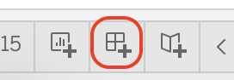

A new screen will appear for creating and organizing your dashboard layout.

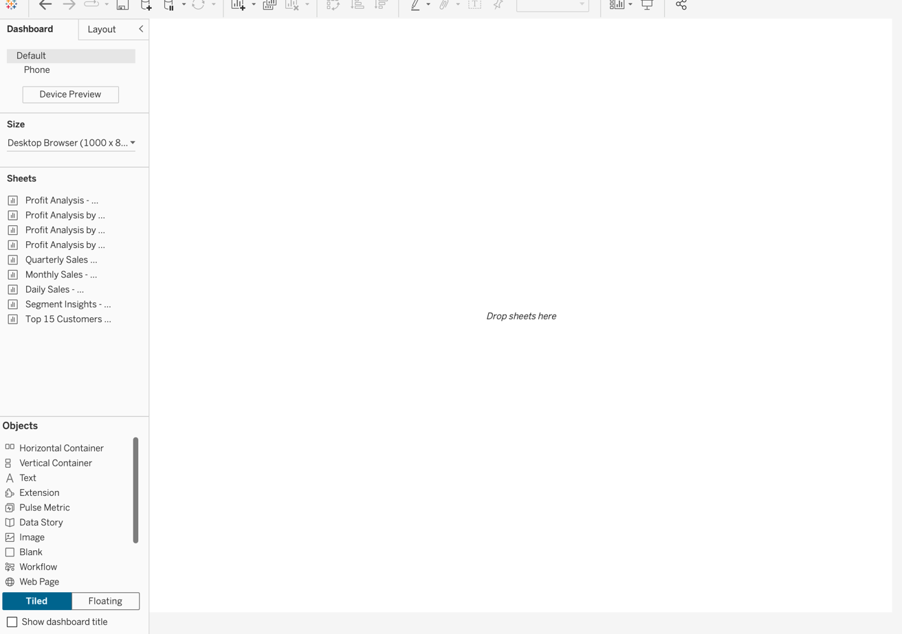

* Drag the **Profit Analysis - <Student Name>** sheet and drop it on the **left side** of the dashboard.
* Drag the **Quarterly Sales** **Trends** **- <Student Name>** sheet and drop it on the **right side** of the dashboard.
* Drag the **Segments Insight** **- <Student Name>** sheet and drop it at the **top** of the dashboard.
* When you drop the **Segment Analysis Sheet**, a card will appear.Click the triangle at the top of the card and select **Floating**.

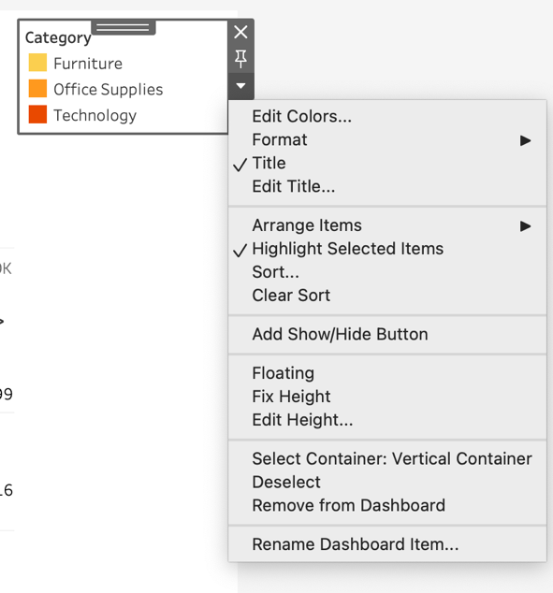

By doing this, you can now move the card anywhere on the dashboard.

Ensure proper alignment so that both the card and the graph are clearly visible and positioned next to each other.

Follow the same steps to adjust the card position for the **Quarterly Sales Trend Graph** as well.

After placing all the sheets, your dashboard will look like the following:

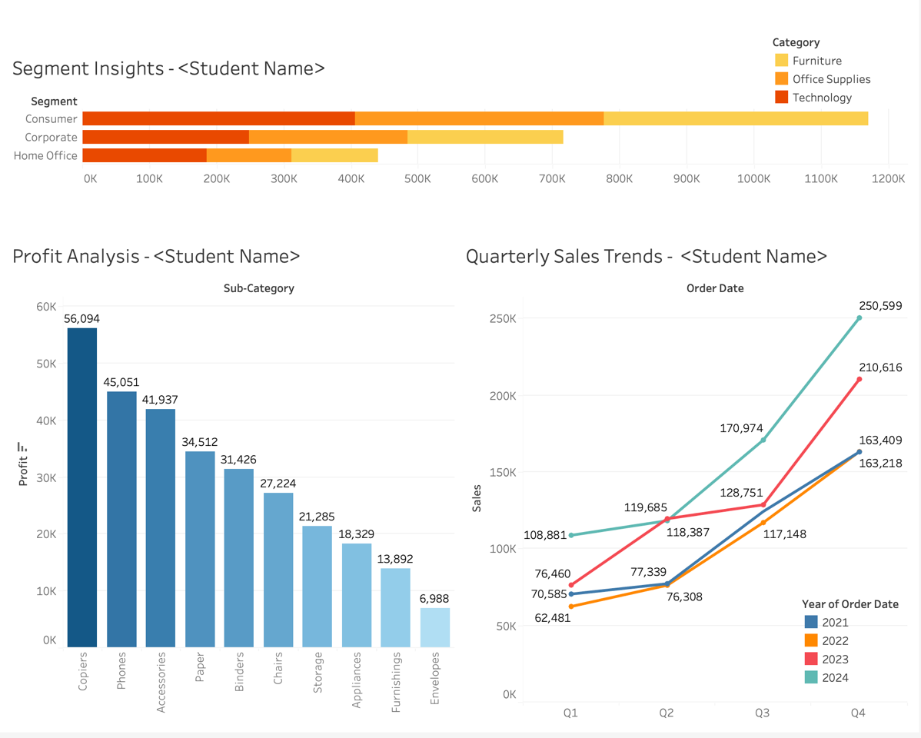

* Click on the **Show Dashboard Title** option located on the left side of the screen.

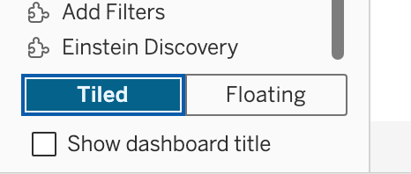

* Click on the Title of the Dashboard
* Change the title to **Superstore Dashboard - < Student Name>**
* Center the alignment of the title by selecting the alignment options.
* Select the font as **Tableau Bold** from the font options. Select Size 18. Click OK.

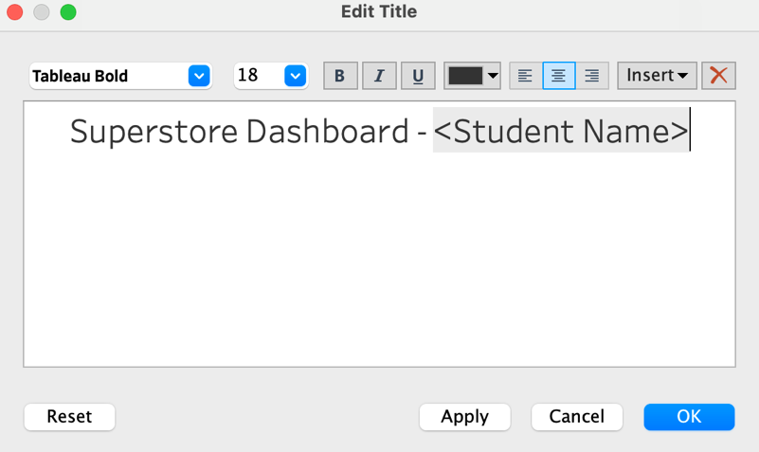

* Click on any graph within the dashboard.
* Navigate to the **Layout** tab and select a color for the **background**. This will apply the chosen background color to your dashboard.
* Select each of the remaining sheets in the dashboard and apply the same background color.

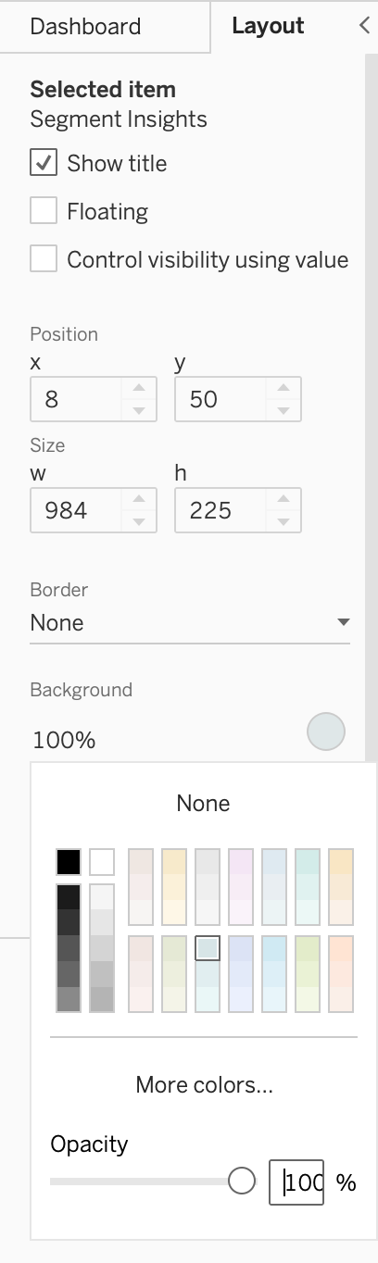

Since we have all the values (Profit, Sales) for the Top 10 Subcategories, we will now add a subheading to summarize this

• Click on **Text** in the **Objects** section.

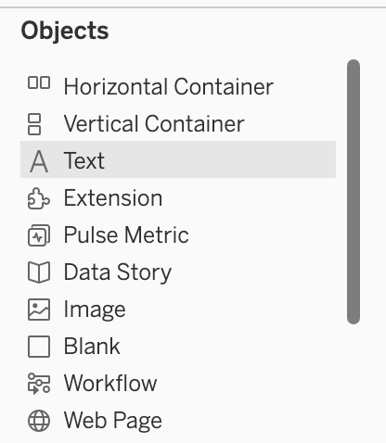

* A text editing window will appear. Write **"Insights on the Top 10 Subcategories"**.
* Set the font to **Tableau Bold** and the size to **14**.
* Align the text to the **center**.
* Drag and drop the text box below the title of your dashboard.

It will look like this once completed, with the subheading placed neatly below the dashboard title.

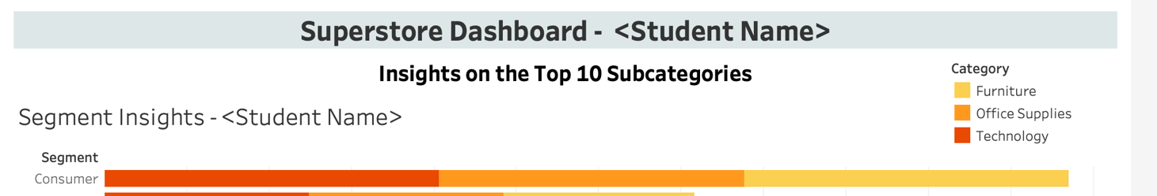

**Question 10: Paste the screenshot of your Dashboard.**

**Access Dashboard Actions:**

* Click on the **Dashboard** option in the top menu, then select **Actions** from the dropdown menu.

* Click on the **Add Action** button. Select **Filter** from the options.

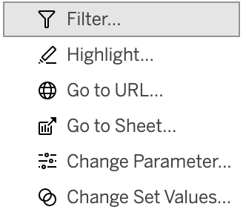

* Make the following changes and Click OK.

* Click on the **Add Action** button again.
* Choose **Go to Sheet** from the options.
* Set the **Source Sheet** to **Profit Analysis - <Student Name>**.
* Set the **Target Sheet** to **Profit Analysis by Region** **- <Student Name>**.
* Select **Run Action On** as **Select**.

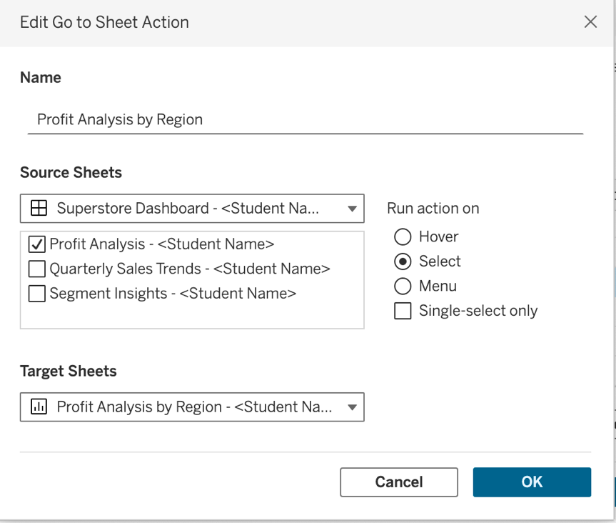

* Click on OK.
* Click on the Add Action. Choose **Go to Sheet** from the options.
* And Make the following changes to get Profit Analysis for Region - State:

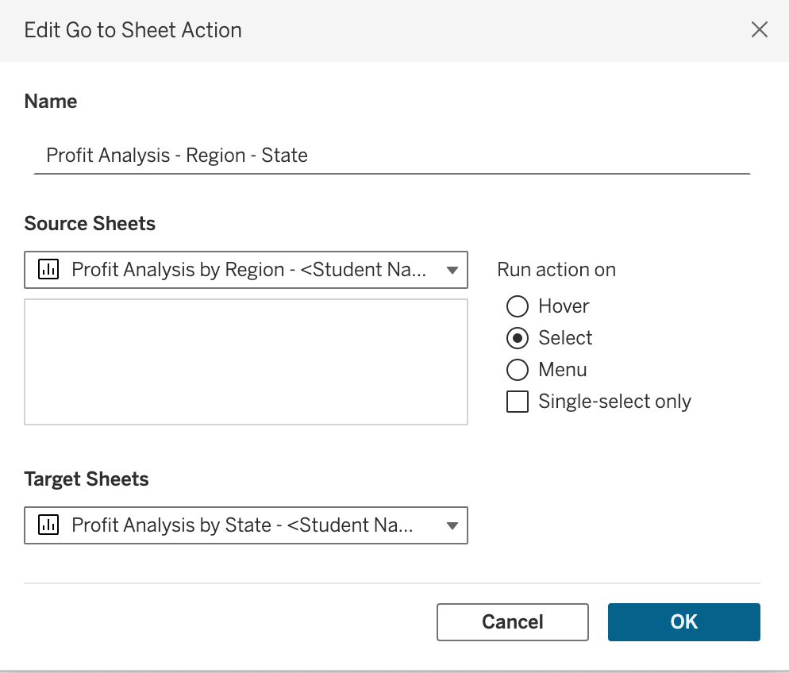

* Similarly, add one more Action for Profit Analysis for State - City.

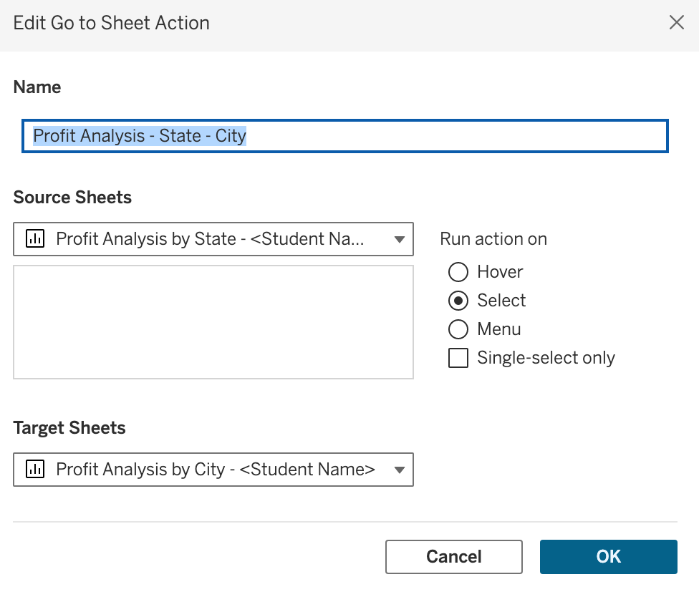

You will now have a total of **three Go to Sheet Actions** present.

* Click on the **Add Action** button again.
* Choose **Go to Sheet** from the options.
* This time Set the **Source Sheet** to **Quarterly Sales Trends - <Student Name>**.
* Set the **Target Sheet** to **Monthly Sales Trends**. **- <Student Name>**.
* Select **Run Action On** as **Select**. Click OK.

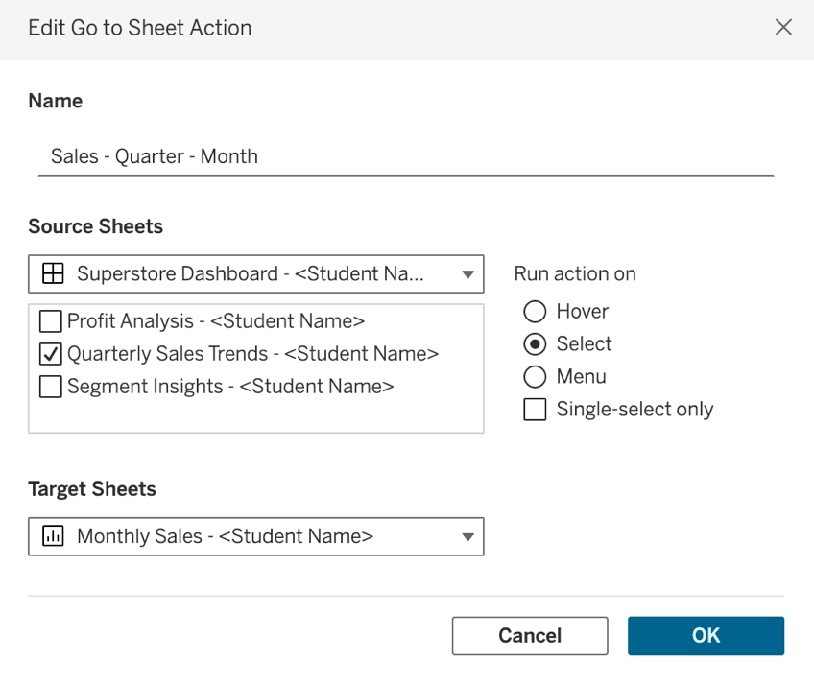

* **Follow This step again to create Go to Sheet action for Month – Days.**
* Add the last action Create a "Go to Sheet" action from Segment Insights to Top 15 Customers.

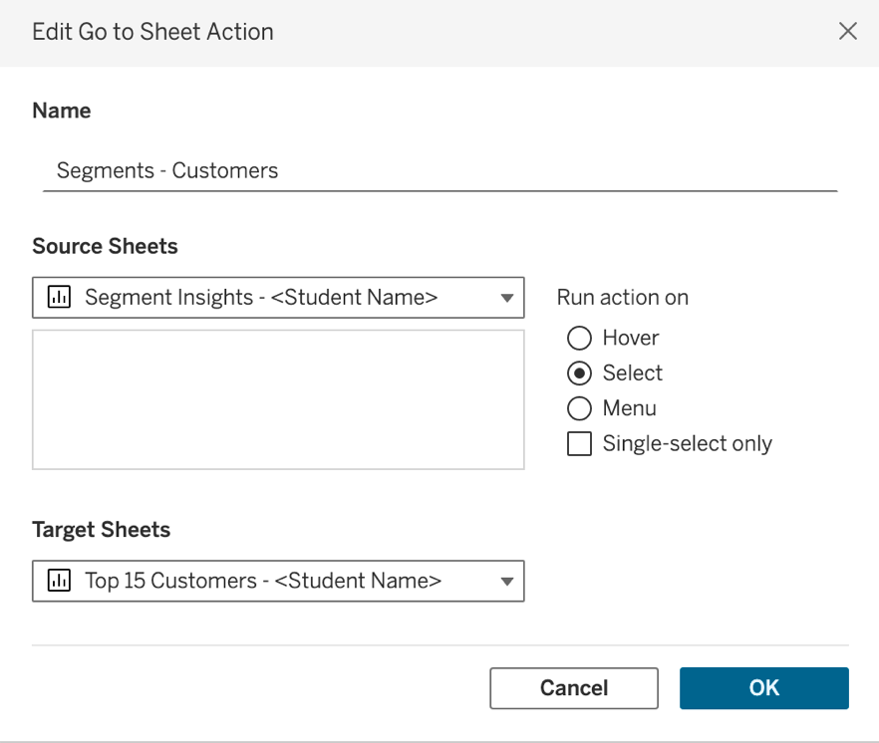

You will now have a total of **six Go to Sheet Actions** present **and one filter action** present.

* Click on OK.

You will notice that when you hover your mouse over the data, the information in each visualization updates accordingly.

Additionally, when you click on the visualization, it navigates to the corresponding sheet as defined by the "Go to Sheet" actions.

From the File menu at the top left, save your file as “Superstore_Dataset_Firstname_Lastname”. Make sure to save the file as .TWBX. Submissions using any other extension will receive heavy discounting.

**Step 6: Connecting Data to Tableau Cloud**

**Setup:**

* Login using the following link:

<https://sso.online.tableau.com/public/idp/SSO>  
  
After clicking the link, you will be directed to the following screen. Enter your credentials as prompted.

Click on Sign In and provide your username, password.

You will see a main screen that looks like this:

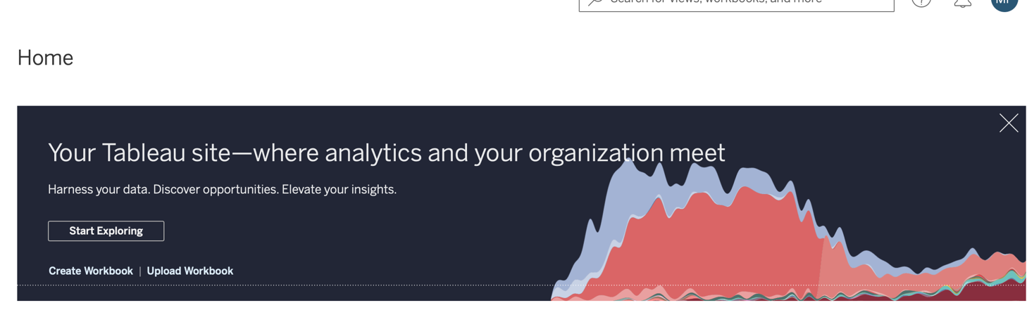

* Question 11: Paste the screenshot of the resulting screen.  
    
    
  Click on ****Upload Workbook****.
* Click on **Choose File** and select the file named **Superstore_Dataset_Firstname_Lastname**.

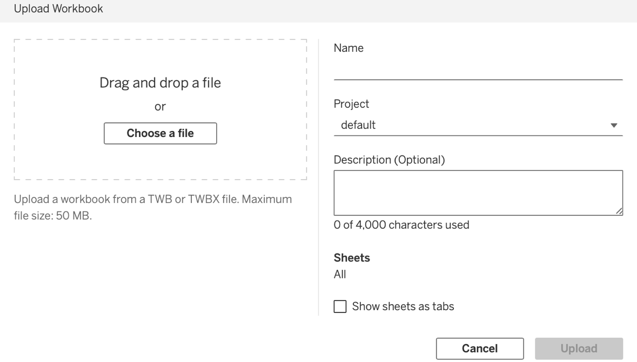

* Click on Upload.

Question 12: Paste the screenshot of the resulting screen.

Question 13: Hover your mouse over the **Copiers** section in the **Profit Analysis** dashboard. You will notice changes in the dashboard as you hover. Paste the screenshot of your screen when you hover over the **Copiers**.

**Navigate Back to Tableau Cloud Main Screen:**

1. Return to the main screen of your Tableau Cloud.
2. Click on **Tableau Pulse**.

Question 14: Paste the screenshot of your Tableau Pulse.

Step 7: Creating matrices for Tableau Pulse

* Click on the New Metric Definition

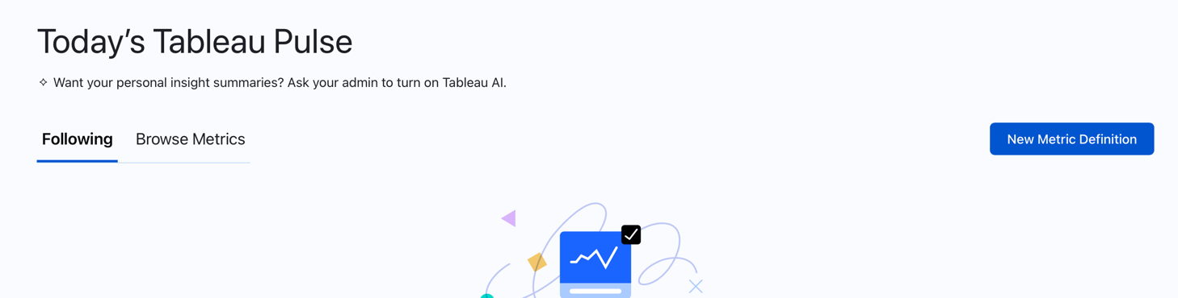

* Click on the **Superstore Dataset**.
* Click on ****Connect****. This will connect Tableau Pulse to the dataset.

You will see a screen that looks like this:

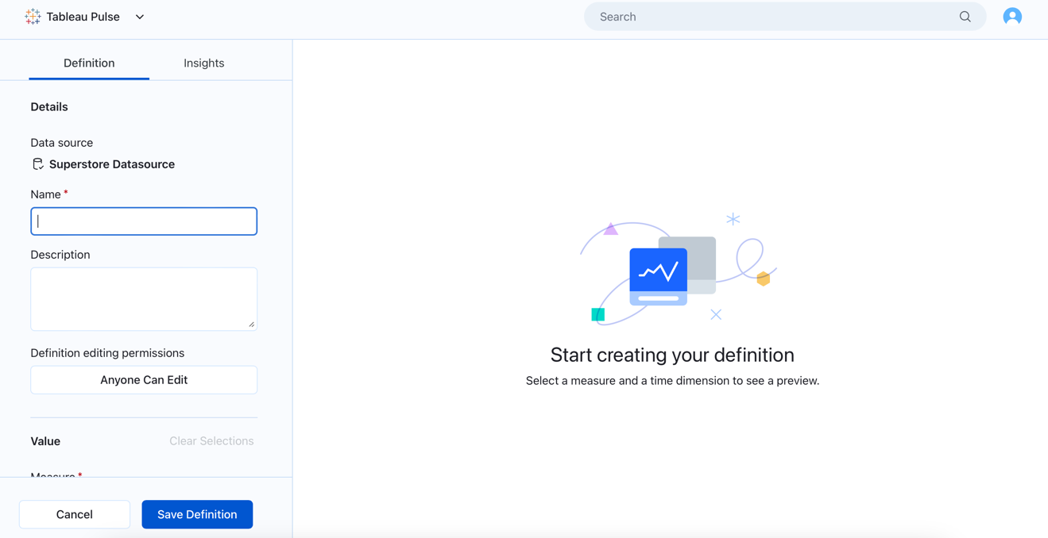

* **Name:** Enter **Profit**.
* **Description:** Input the following:  
  "This metric displays the total profit generated from each product, allowing users to filter and analyze performance by region, state, and sub-category."
* **Select Measure:** Choose **Profit**.
* ****Time Dimension:**** Select ****Order Date****.

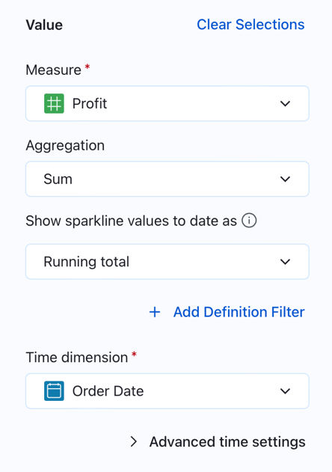

Scroll down and select the adjustable options for **Profit** as follows:

1. **Region**
2. **Sub-category**
3. **State/Province**

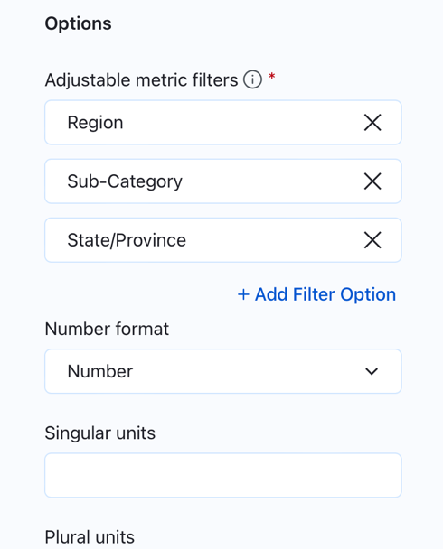This step will allow you to look at profits specifically for certain areas or types of products, making it easier to see where your profits are coming from.  
  
Click on the Insights Section  
  
* Choose the values that are increasing and label them as ****Favourable****.

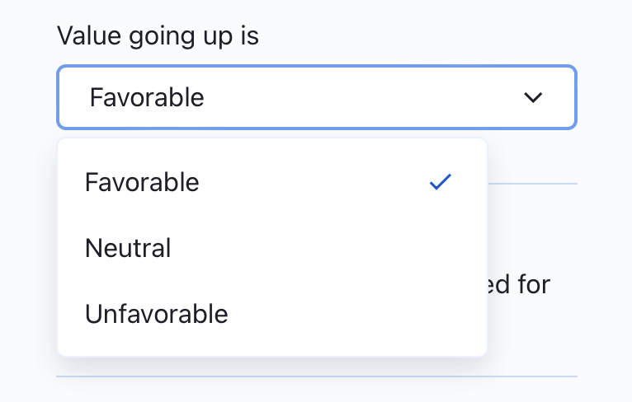

* Turn Off the Record Level Outliers

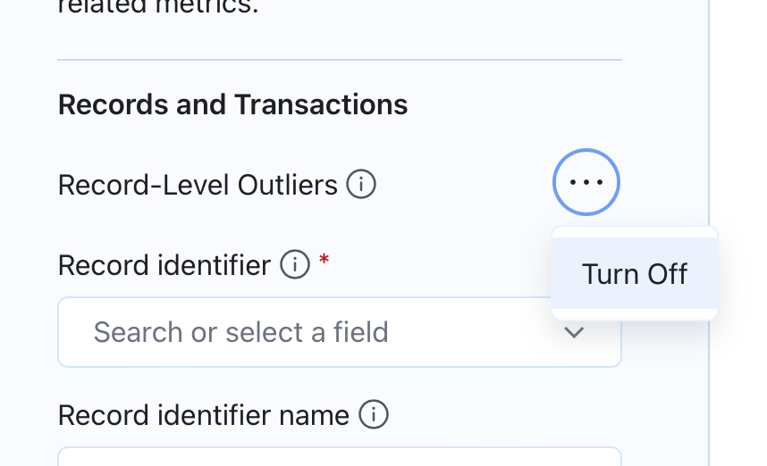

* Click on the Save Definition button

Question15 : Paste the screenshot of the resulting screen.

Copy the ****URL**** and save it in your ****Notepad****.

Scroll down, and you will see a screen that looks like this:

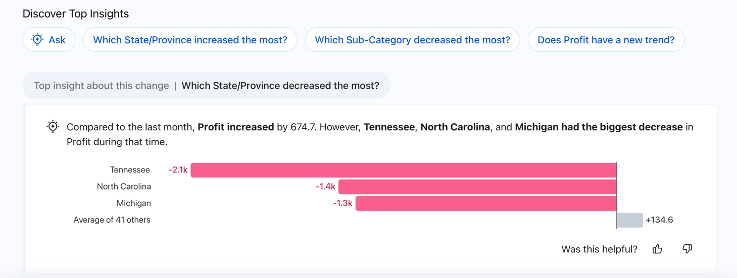

**Ask Data in Tableau Pulse:**

The **Ask Data** feature in Tableau Pulse lets you ask questions about your data in everyday language. You can type things like "What are the total sales by region?" and get quick answers in the form of charts and graphs. This makes it easy for anyone to explore and understand their data, even if they don’t have a technical background.

* Click on the first three questions that Tableau Pulse's Ask Data feature recommends.
* You will see the answers presented in the form of visualizations.

Question 16: Paste the screenshot of the first three questions along with the answers provided by Ask Data.

* Click on the **Ask** button.

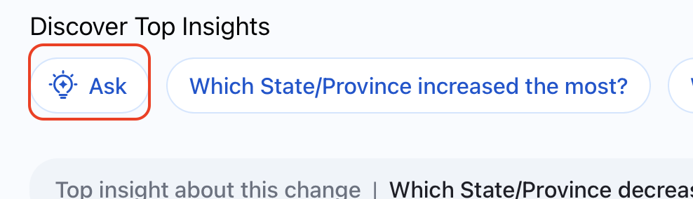

You will see a screen that looks like this.

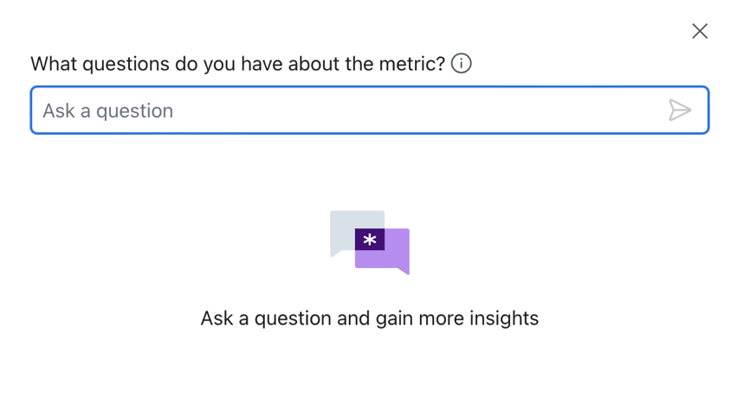

* Write three questions of your choice, different from the recommendations provided by Tableau Pulse. Ask Data will generate visualizations to answer your questions.

**Question 17: Paste the screenshot of the three questions you asked along with the corresponding visualizations.**

* Click on the **Filter** button.

* Select **Last Quarter** for the time period.
* For **Region**, select **All**.
* For **Subcategory**, choose **Accessories**.
* **For State, select All.**

Click on the Ok.

Question 18: Paste the screenshot of the resulting screen.

* Click on the Follow Button.

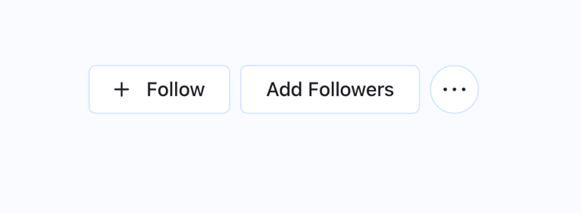

Go back to the **Tableau Pulse** screen. You will now be able to see the metric you have created.

* Click on **New Metric Definition**.
* We will now create a metric for **Sales**.
* **Name:** Total Sales
* **Description:** This metric provides a detailed breakdown of sales by product name, helping to identify the most successful product lines.
* **Measure:** Sales
* **Time Dimension:** Order Date
* **Adjustable Filters:** Sub-category, Product Name
* Click on the Insights Section

Make the below changes in Value going up and Record Identifier:

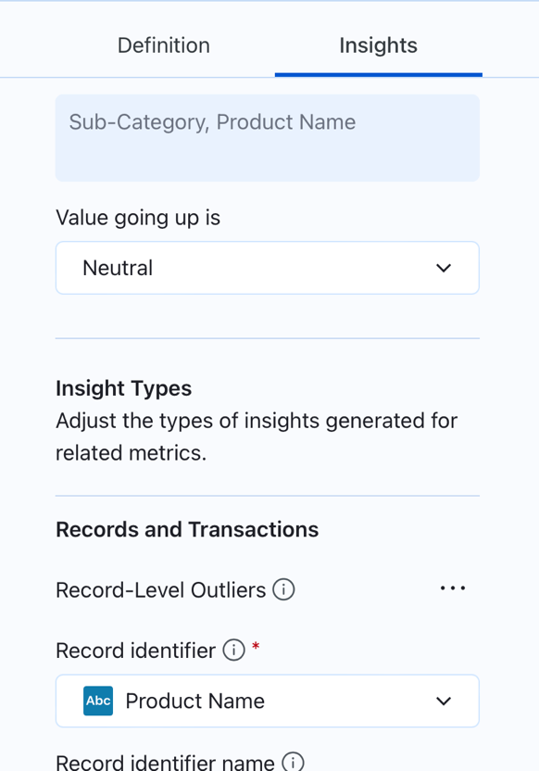

* Click on the Save Definition button

Question 19: Paste the screenshot of the resulting screen.

Copy the ****URL**** and save it in your ****Notepad****.

* Scroll down to the **Ask Data** feature.
* Just like we did with the **Profit** metric:
* **Question 20: Paste the screenshots of the first three questions Ask Data is suggesting, along with the answers provided.**
* **Question 21: Write your own three questions in the Ask Data feature (different from the recommendations), and paste screenshots of those questions along with the answers generated by Ask Data**.
* Click on the Follow Button.

**Question 22: Navigate back to the Tableau Pulse screen and Paste the screenshot of your matrices**

**Step 8: Commecting Tableau Cloud and Tableau Pulse**

* Click on the **arrow** next to **Tableau Pulse** and select **Tableau Cloud**.

* Open the **Superstore Dashboard** that you have created.
* You will see the **Dashboard** you have created. Click on **Edit** and navigate to your **Dashboard**.

**Adding a Link to Your Dashboard:**

* Go to your **Dashboard**.
* Click on **Text** from the **Objects** section.

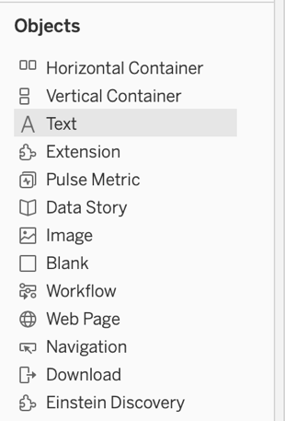

* Select the **Link** option as shown below.

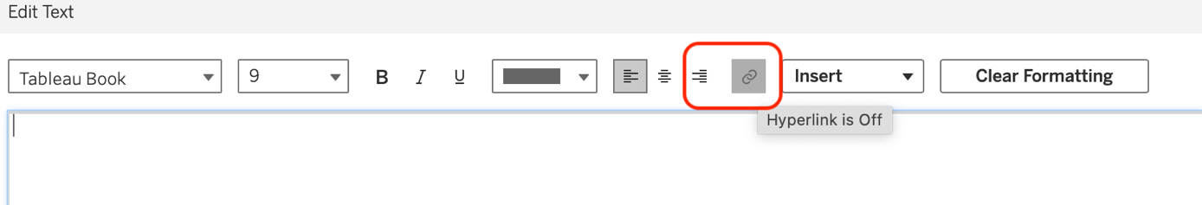

* Write the text as **Profit**.
* Paste the **link** you have copied from **Tableau Pulse** for the **Profit** metric.

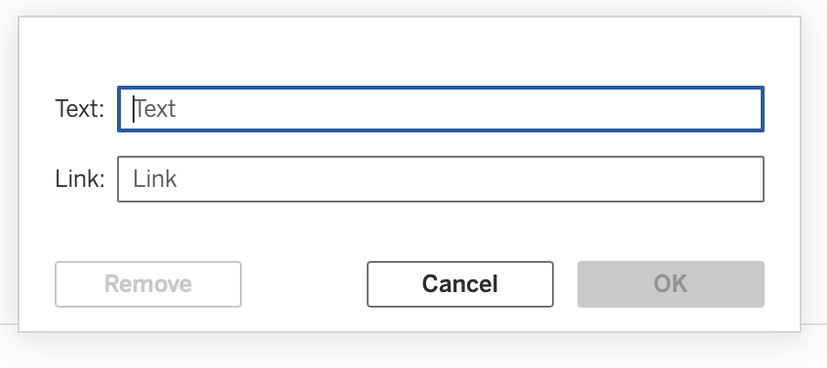

* Click **OK** to save the changes.
* Select the link you just created.

* Right-click on the link and select **Floating**.

* Drag the link you created. Paste it near the visualization where you have displayed the **Profit for the Top 10 Subcategories**.
* Follow the same process to create a link for **Sales**.
* Write the name as **Sales**.
* Paste the link you have copied for **Sales**.
* Position it near the visualization where you have calculated **Quarterly Sales**.

Question 23: Paste the screenshot of the resulting screen.

Click on ****Publish**** to save your changes.

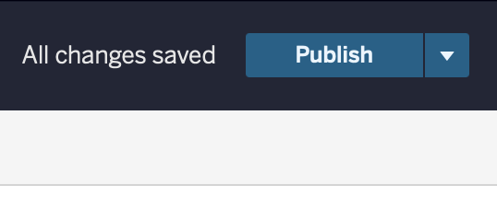

**Accessing Device Layouts:**

1. Go back to your **Dashboard**.
2. Click on the **Device Layouts** icon in the top right corner.
3. You will see device layouts for **Desktop**, **Tablet**, and **Phone**.

**Question 24: Click on each layout and paste a screenshot of each layout.**

**Downloading the Tableau Workbook:**

1. Click on the **Download** button.

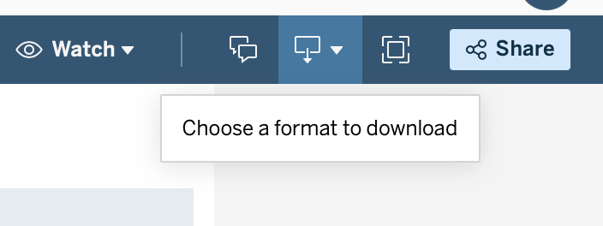

1. Select **Tableau Workbook and Download the file**.
2. Ensure the file is downloaded in **.twbx** format.

**Instructions:**

1. Submit the assignment document in Microsoft Word to eLearning.
2. Submit your TWBX file on eLearning .
3. Include only screenshots and answers with proper question numbers. For any additional step/instruction or improper question numbering your assignment will be discounted.